**ISDS 552**

**Project on**

**Car Dealership (Sales)**

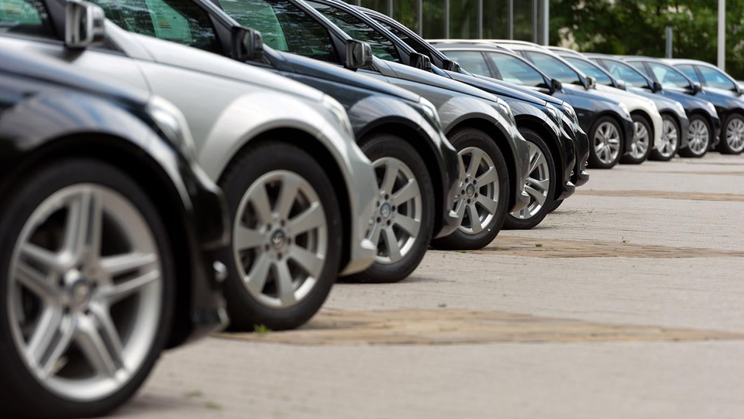

**By**

**Team- S3**

**Deepam Khirwar**

**Harshita Didwania**

**Kavindu Walimunige**

**Sanchit Singh**

**Sathiya Priya Jeevanandan**



**WND Diagram**

**Match Vehicles with Customer**

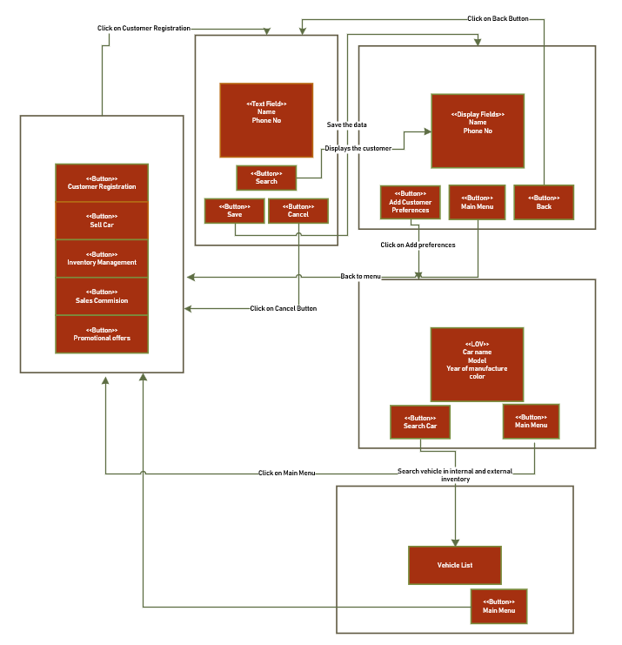

**GUI Diagram**

**Match Vehicles with Customer**

